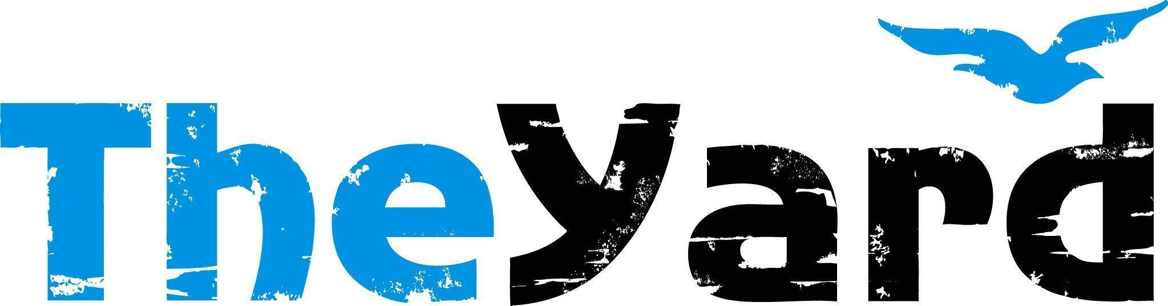
Post Office Box 405, Chilmark, MA 02535-0405
508.645.9662 I info@dancetheyard.org I dancetheyard.org
A contemporary artist residency, dance and performance center,
for Martha’s Vineyard and beyond

CONTACT:
Yvonne Mendez, Acting Executive Director - (413) 218-1353
Fiona MacLean, Marketing & Development Manager - (831) 419-2077

FOR IMMEDIATE LISTING and RELEASE
May 9th, 2023

THE YARD ANNOUNCES 2023
SUMMER SEASON PROGRAMS

[May 9th, 2023] — (Chilmark, Massachusetts)

This summer we are officially celebrating our 50th anniversary and we’re commemorating this momentous year with yet another cohort of world -class artists, companies, and dance educators.
Our 2023 artists-in-residence are pushing boundaries and confronting big questions. They are a dynamic group of artists and storytellers, movers and magic makers — together they form an eclectic season built on a wide range of dance disciplines. From tap and samba to puppetry to a multi-media, black-light-on-paint creation story, this summer has something to inspire everyone!

What to expect at a glance:
- In-person classes such as yoga, East African Dance with Godfrey Muwulya, three sessions of Kids Do Dance, and more!
- Artist-led workshops open to all ages and abilities.
- Performances and other events across the island.
Visit dancetheyard.org to learn more about this summer’s lineup of residencies and classes.
_____
2022 Summer Residencies and Performances

Launch Pad: A Choreographers' Showcase
In Residence: May 31 - June 12, 2023
Performance: June 10 | Patricia N. Nanon Theater

Box Office Info:
The Yard’s Patricia N. Nanon Theater
$30 Adult
$25 Senior 65+/Military
$10 Youth under 18
*Every ticket will be subject to a $3 service fee.

_____

Sandglass Theater
In Residence June 14 - June 26, 2023
Performance: June 24 | Patricia N. Nanon Theater

Box Office Info:
The Yard’s Patricia N. Nanon Theater
$30 Adult
$25 Senior 65+/Military
$10 Youth under 18
*Every ticket will be subject to a $3 service fee.

_____

Sean Dorsey Dance
In Residence: July 3 - July 10, 2023
Performances: July 7 + 8 | Patricia N. Nanon Theater

Box Office Info:
The Yard’s Patricia N. Nanon Theater
$30 Adult
$25 Senior 65+/Military
$10 Youth under 18
*Every ticket will be subject to a $3 service fee.

_____

Music From the Sole
In Residence: July 12 - July 17, 2023
Performance: July 15 | Martha’s Vineyard Performing Arts Center

Box Office Info:
MV Performing Arts Center (PAC)
$40 Adult
$35 Senior 65+/Military
$10 Youth under 18
*Every ticket will be subject to a $3 service fee.

_____

Rainbow Serpent Collective
In Residence July 19 - 31, 2023
Performance: July 29 | Patricia N. Nanon Theater

Box Office Info:
The Yard’s Patricia N. Nanon Theater
$30 Adult
$25 Senior 65+/Military
$10 Youth under 18
*Every ticket will be subject to a $3 service fee.

_____

Urban Bush Women
In Residence: August 1 - August 14, 2023
Performances: TBA | Multiple locations around the Island

Box Office Info: TBA

_____

Caleb Teicher and Nic Gareiss
In Residence August 16 - August 21, 2023
Performances: August 19 + 20 | Patricia N. Nanon Theater
Free Pop-up Performances: August 17, 18, + 19

Box Office Info:
The Yard’s Patricia N. Nanon Theater
$30 Adult
$25 Senior 65+/Military
$10 Youth under 18
*Every ticket will be subject to a $3 service fee.

_____

Classes: (This is a dynamic class list. Classes and workshops will be added throughout the summer.)

Workshops with the Artists
Ongoing during residencies throughout summer.

Modern Dance for Life with Naomi Goldberg Haas:
Classes June 26 - 30 (M-F) | 10:30 - 11:30 am

East African Dance & Drumming with Godfrey Muwulya

Classes at The Yard | Wednesday, July 19th and Saturday, July 22 at 10:30 am - 12 pm
Classes at The Boys & Girls Club | Tuesdays, July 18th and July 25 at 1 - 2:30 pm

Yoga with Mollie Doyle
Classes Late June - End of August | Tuesdays 7 am and Saturdays 8 am

Kids Do Dance
Monday-Friday | 9:30am - 12pm
Session 1: June 26 - 30, 2023 | Session 2: July 10 - 14, 2023 | Session 3: August 14 - 18, 2023

_______
The Yard Summer Season Sponsors

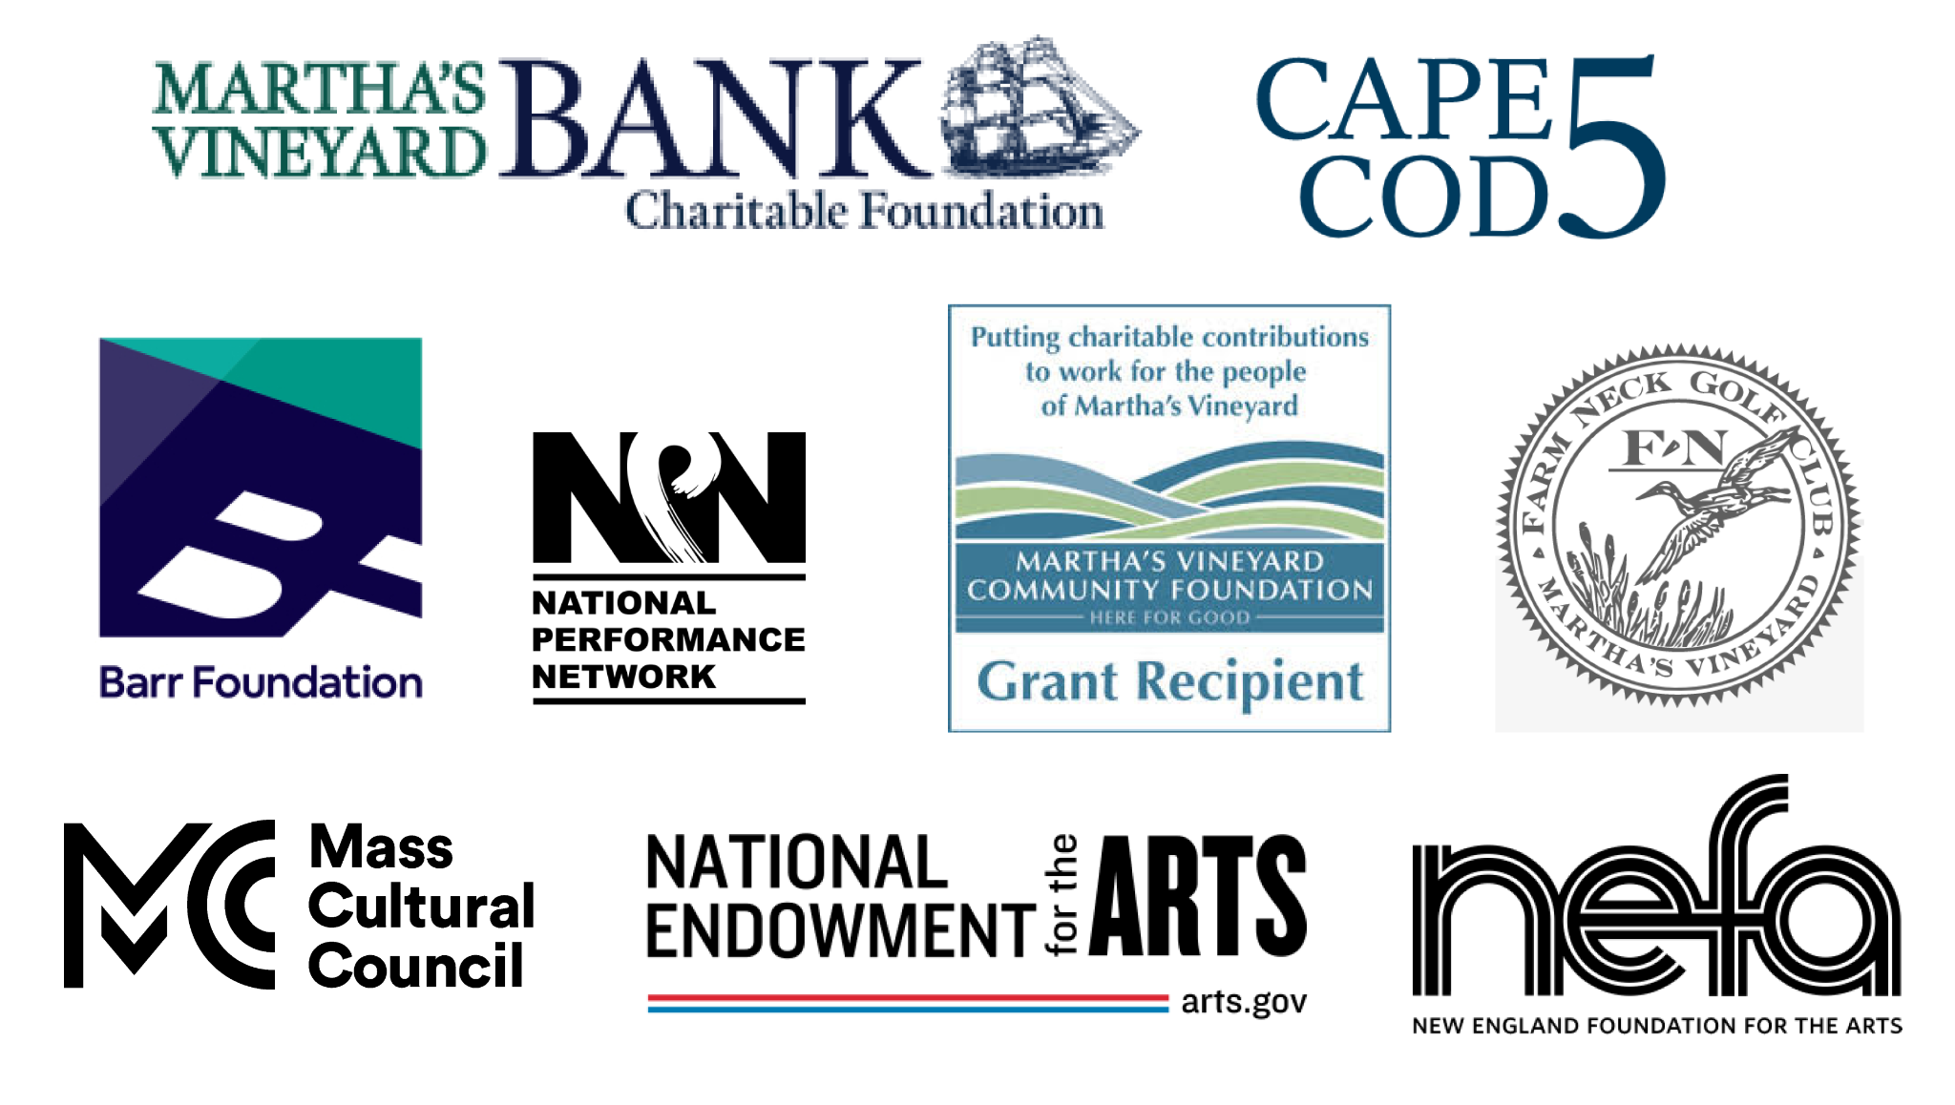

####
The Yard is a creation and performance platform for artists from around the globe, and we offer exhilarating, wide-ranging, and educational arts experiences through performances, residencies, and community activities. We present performances by international, national, and local artists; provide paid residencies for artists; offer inter-generational engagement programs and classes for our island community; and bring dance and creativity-centered education programs into schools. Our community programs run year-round and can be found on The Yard’s campus and in partner locations across the island of Martha’s Vineyard. Please visit www.dancetheyard.org for more information.

SEED. GROW. REAP. REPEAT: THE NATURE OF THE YARD.

