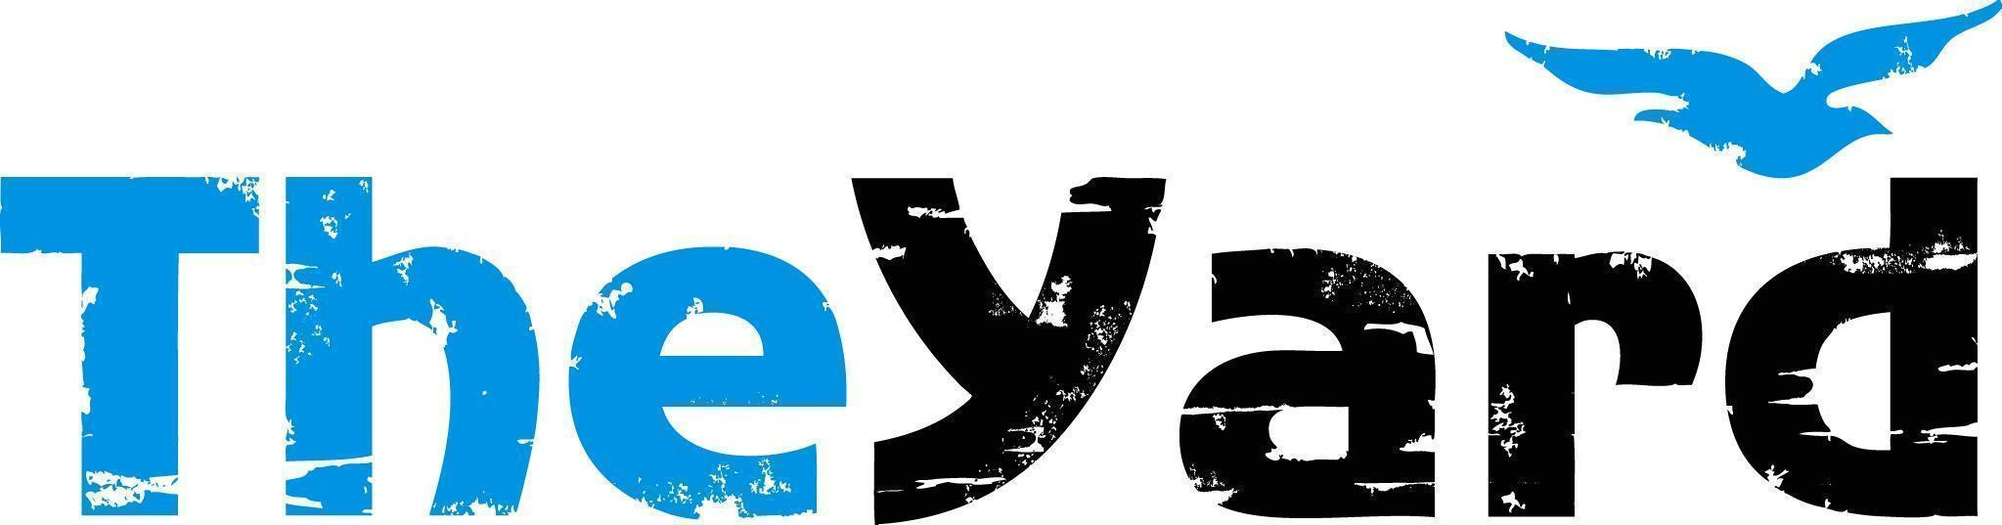
Post Office Box 405, Chilmark, MA 02535-0405
508.645.9662 I info@dancetheyard.org I dancetheyard.org
A contemporary artist residency, dance and performance center,
for Martha’s Vineyard and beyond

CONTACT:
Leslie Trotter, Marketing Manager: leslietrotter@dancetheyard.org

FOR IMMEDIATE LISTING and RELEASE
June 27, 2023

Sean Dorsey Dance
In Residence July 3 - 10, 2023
Performances July 7 & 8, 2023 at 7pm

[June 27, 2023] — (Chilmark, Massachusetts) “The Lost Art of Dreaming” is an evening of powerful dance-theater that invites audiences to reconnect with longing, embrace expansive imagination, connect with joy and pleasure, and move toward loving futures. The work is a fusion of full-throttle contemporary dance, intimate storytelling, intricate costuming, and exquisite queer partnering – all performed with Sean Dorsey Dance’s signature technical precision and deep humanity.

Sean Dorsey explains, “At a time when transgender and LGBTQI+ communities across the US are experiencing increased attacks on our bodies, our rights and our creative expression, ‘The Lost Art of Dreaming’ expansively imagines our futures, disrupting long-entrenched constructs that deny our communities the space to dream.” Dorsey is an Emmy Award-winning choreographer, a 2020 Doris Duke Artist and a Dance/USA Artist Fellow. He has been awarded five Isadora Duncan Dance Awards and the Goldie Award for Performance. In 2009, Dorsey was named in Dance Magazine’s “25 To Watch;” in 2019, he became the first openly-transgender person on the cover of Dance Magazine.

“The Lost Art of Dreaming” is performed by a powerhouse ensemble of five queer, trans and gender-non-conforming dancers – with a rich, layered soundscore featuring original and commissioned music.

Details:
Performance Date: July 7th & 8th at 7pm
Location: The Yard, Patricia Nanon Theater, 1 The Yard, Chilmark, MA

Tickets:
Adult: $33
Senior/Military: $28
Youth/Student: $13
Purchase: The Lost Art of Dreaming

Community Activities:
The Yard seeks to engage the Island community with our guest artists. Sean will conduct two activities FREE to the public during his residency, including a Community Conversation rooted in Trans and Queer joy, as well as a Movement Workshop. These programs are provided in partnership with Circuit Arts, West Tisbury Library and Queer Hub MV. Please join us:

A Community Conversation: Sean Dorsey
Moderated by: Scott Mullin from Queer Hub MV
Wednesday July 5th, 2023 5:30pm - 7:30pm
The Grange Hall, West Tisbury, MA

A Movement Workshop with Sean Dorsey
This all-queer/gender-nonconforming/non-binary group will lead the class in mindful breathing, meditation, a gentle warmup, movement exercises, concluding with creative self-expression through movement! For ALL humans and ALL levels – including terrified “non-dancers”!
Saturday July 8th, 2023 11:30am - 1pm
The Dancer’s Studio, The Yard, Chilmark, MA

Upcoming Shows:
Music From The Sole: A company that celebrates the Afro-diasporic roots of tap dance, performing, "I Didn’t Come to Stay”, July 15th at the Martha’s Vineyard Performing Arts Center.
For more information & tickets: Music from The Sole — The Yard

About The Yard
The Yard is a creation and performance platform for artists from around the globe, and we offer exhilarating, wide-ranging, and educational arts experiences through performances, residencies, and community activities. We present performances by international, national, and local artists; provide paid residencies for artists; offer inter-generational engagement programs and classes for our island community; and bring dance and creativity-centered education programs into schools. Our community programs run year-round and can be found on The Yard’s campus and in partner locations across the island of Martha’s Vineyard. Please visit www.dancetheyard.org for more information.

The Yard Access program is designed to make The Yard programs accessible to a wider portion of our community. Find more information here.
- - - -

This program is supported by the following generous sponsors:
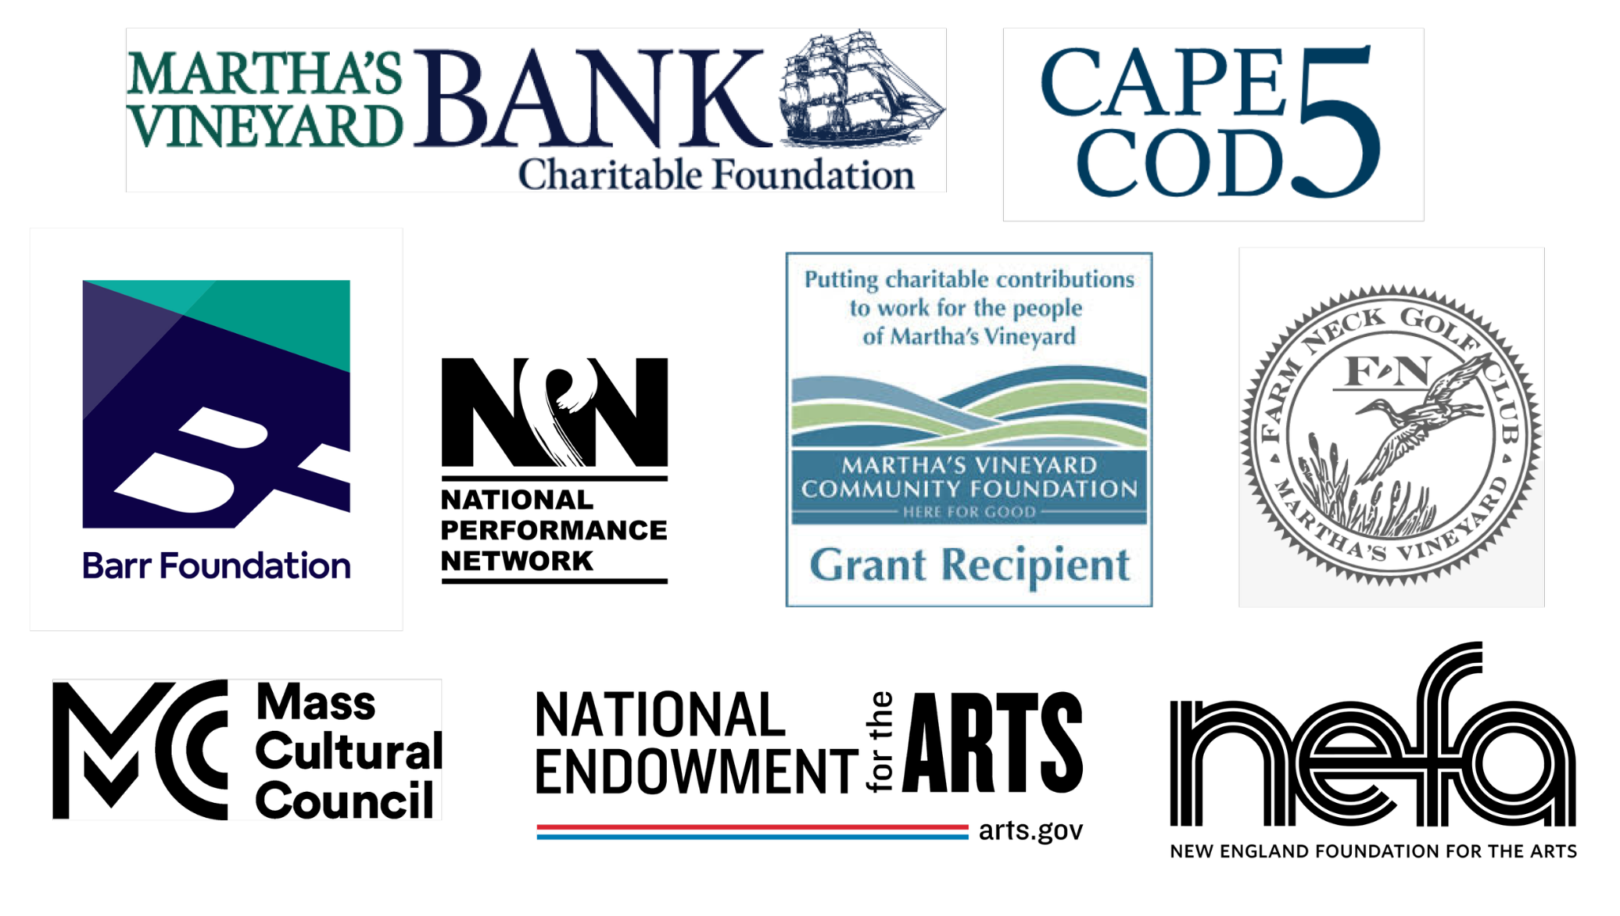

Also by grants from the Jim Henson Foundation, the Network of Ensemble Theaters NET/TEN Virtual Exploration grant and by the National Endowment for the Arts. To find out more about how National Endowment for the Arts grants impact individuals and communities, visit www.arts.gov. Feral is a National Performance Network (NPN) Creation & Development Fund Project grant with co-commissioners The Yard (MA), Next Stage Arts Project (VT), Bunnell Street Arts Center (AK), Dancers Workshop (Wyoming) and NPN. More information: www.npnweb.org.

SEED. GROW. REAP. REPEAT: THE NATURE OF THE YARD.

