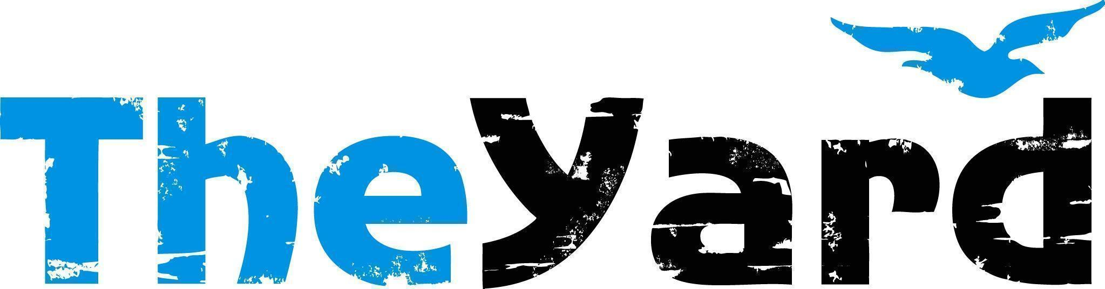
Post Office Box 405, Chilmark, MA 02535-0405
508.645.9662 I info@dancetheyard.org I dancetheyard.org
A contemporary artist residency, dance and performance center,
for Martha’s Vineyard and beyond

CONTACT:
Leslie Trotter, Marketing Manager: leslietrotter@dancetheyard.org

FOR IMMEDIATE LISTING and RELEASE
July 21, 2023

Urban Bush Women
In Residency July 31 - August 14, 2023
Performances August 9 - 12 | Orange Peel Bakery Aquinnah

[July 21, 2023] — (Chilmark, Massachusetts) Urban Bush Women (UBW) burst onto the dance scene in 1984, with bold, innovative, demanding and exciting works that brought under-told stories to life through the art and vision of its award-winning Founder and Visioning Partner, Jawole Willa Jo Zollar. The company continues to weave contemporary dance, music, and text with the history, culture, and spiritual traditions of the African Diaspora under the artistic direction Co-Artistic Directors of the UBW Company, Chanon Judson and Mame Diarra Speis.

Haint Blu is an ensemble dance-theater work seeped in memory and magic. Known as the color that Southern families paint their front porches to ward off bad spirits, Haint Blu uses performance as a center and source of healing, taking us through movement into stillness and rest: remembering, reclaiming, releasing, and restoring. It is an embodied look into familial lines and the movements, histories and stories of our elders and ancestors. It reflects on what has been lost across generations and what can be recovered. Haint Blu takes us to the magical place where spirits share their legacies, journey onward, and leave the thick residue of their knowledge behind. Haint Blu is inspired by SCAT!, Urban Bush Women’s musical theater work in development.

Urban Bush Women performs regularly in New York City and tours nationally and internationally. The Company has been commissioned by presenters nationwide, and includes among its honors a New York Dance and Performance Award (“Bessie”); the Capezio Award for Outstanding Achievement in Dance; a Black Theater Alliance Award; two Doris Duke Awards for New Work from the American Dance Festival; and named one of America’s Cultural Treasures by the Ford Foundation.

Details:
Performance Dates: August 9 - 12, 2023, 7pm
Location: Orange Peel Bakery, Aquinnah

Tickets:
Adult: $33
Senior/Military: $28
Youth/Student: $13
Purchase: Haint Blu

UP NEXT AT THE YARD

Community Activities:
Miracles in Motion: A Dance Healing Workshop
Wednesday, July 26th at 10:30am | The Studio at The Yard
This one-hour workshop with Rainbow Serpent Collective is open to people of ALL LEVELS. Miracles in Motion is a dance modality that promotes healing on physical, spiritual, mental, and energetic levels. Through guided meditation, choreography, and improvisation, this workshop introduces participants to dance rituals, dance energy healing, quantum jumping, and somatic psychotherapy techniques. Come to find freedom, joy, and healing in the movement of dance!
Buy tickets: Classes and Workshops — The Yard

Movement Workshop with Urban Bush Women
Wednesday, August 2nd at 10:30am | The Studio at The Yard
Buy tickets: Classes and Workshops — The Yard

Visit our website’s calendar for a comprehensive view of our summer programming.

Upcoming Shows:
Caleb Teicher & Nick Gareiss
Performances August 18 & 19, 2023 at 7pm | The Patricia Nanon Theater**
In this new 60-minute duo collaboration, Teicher and Gareiss explore improvisation, song, and percussive dance. Drawing on American tap dance, jazz, swing, lindy hop, Appalachian clogging, and Irish step dance, they create a breathtaking evening of dance rooted in time and place yet uniquely their own; a festive dialogue of sound, movement, and corporeal rapport. Click here for more information & tickets.
**There will also be multiple FREE pop-up performances at farm stands around the Island on August 17, 18, & 19. Stay tuned for details.

About The Yard
The Yard is a creation and performance platform for artists from around the globe, and we offer exhilarating, wide-ranging, and educational arts experiences through performances, residencies, and community activities. We present performances by international, national, and local artists; provide paid residencies for artists; offer inter-generational engagement programs and classes for our island community; and bring dance and creativity-centered education programs into schools. Our community programs run year-round and can be found on The Yard’s campus and in partner locations across the island of Martha’s Vineyard. Please visit www.dancetheyard.org for more information.

The Yard Access program is designed to make The Yard programs accessible to a wider portion of our community. Find more information here.
- - - -

This program is supported by the following generous sponsors:
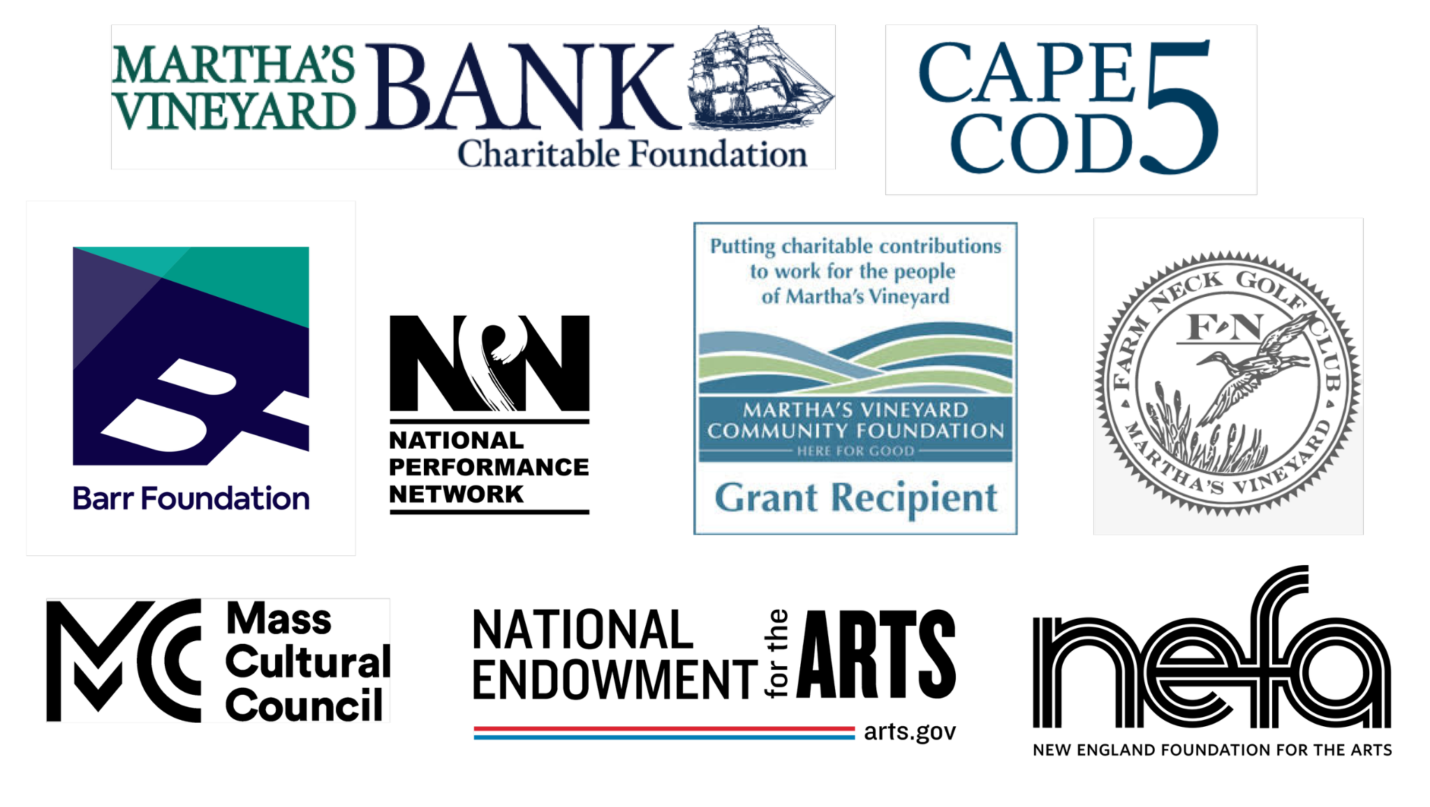
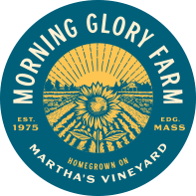
Initial Haint Blu creative community partners include: Live Arts Miami and Miami Dade College in partnership with Hampton House, New Orleans Coalition including Junebug Productions, Ashe Center and the New Orleans Contemporary Arts Center, Berkshires Coalition including MASS MoCA, Jacob's Pillow, and Williams College Dance Department, The Yard and the Community of Martha's Vineyard. Haint Blu has also received commissioning support from Wesleyan University Center for the Arts, Hopkins Center for the Arts at Dartmouth, NPN Creation Fund, LMCC's Residency Program, Arts & Culture on Governors Island, and Lumberyard's Technical Rehearsal Program.
MAJOR FUNDING FOR URBAN BUSH WOMEN IS PROVIDED BY: Anonymous; Acton Family Foundation; A.R.T./New York/Mellon Foundation; Bloomberg Philanthropies; David Rockefeller Fund; Doris Duke Charitable Foundation; Ford Foundation; The Howard Gilman Foundation; The Institute of Museum and Library Services; International Association of Blacks in Dance; Lily Auchincloss Foundation, Mellon Foundation; Mid-Atlantic Arts Foundation; National Endowment for the Arts (NEA); National Performance Network; New England Foundation for the Arts - National Dance Project; New York Community Trust Mosaic Fund; New York Community Trust Van Lier Fellowship Program; New York State Council on the Arts; New York City Department of Cultural Affairs; The Shubert Foundation; Solidaire Black Liberation Pooled Fund; William Talbott Hillman Foundation; Barnard College Center for Research on Women, Barnard College Office of Community Engagement & Inclusion

SEED. GROW. REAP. REPEAT: THE NATURE OF THE YARD.

